Empty space

- Imagine you could see the particles in this jar of methane gas.

Which diagram best matches what you would see?

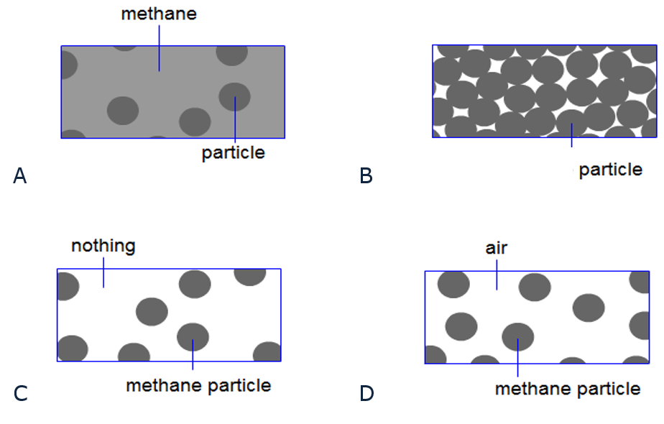

Chemistry > Big idea CPS: Particles and structure > Topic CPS1: Substances and mixtures: > Key concept CPS1.1: A particle model for the solid, liquid and gas states
Diagnostic question
Empty space

Learning focus: | Understand a basic particle model of matter that can explain the properties of substances in the gas state.
Observable learning outcome: | Describe how the arrangement and movement of particles alters when a substance changes from the liquid to gas state.
Question type: | simple multiple choice
Key words: | gas, state, particle

What does the research say?
Research by Johnson (1998) shows that the empty space between particles is problematic for many students. Often it is labelled as ‘air’. However, it is not clear what students consider air to be. A later study by Johnson and Papageorgiou (2010) also indicates that many students have very limited understanding of what a substance in the gas state actually is or that it is in fact a substance at all.
Ways to use this question
Students should complete the question individually. This could be a pencil and paper exercise, or you could use an electronic ‘voting system’ or mini white boards and the PowerPoint presentation.
The answers to the question will show you whether students understood the concept sufficiently well to apply it correctly.
Expected answers
1 C
How to respond - what next?
This question explores the relationship between the particles and the substance for a sample in the gas state and the idea of empty space between the particles. Those choosing option C appreciate that the particles are the substance, they are spaced far apart and there is empty space between the particles - not something else, since the particles are the substance, methane. These students could still be thinking that the individual particles have the macroscopic properties of the gas state. However, research suggests that if a student understands the idea of empty space he or she will also understand that observed properties are due to the collective behaviour of particles and not their individual nature.
It is not always clear how students interpret ‘air’ in option D, but this is likely to be a popular choice since many want ‘something’ to be there between the particles and they are not thinking that air itself is particulate. Option C acknowledges a particulate view but has the particles filling all the space, thus avoiding the issue of what is between the particles. Option A is consistent with the idea of particles being embedded in the continuous substance but not of it– literally ‘in the gas’.

If students have misunderstandings about what is found in between particles in the gas state it may help for them to consider the change from liquid to gas state. As the particles move apart no other substance is added to fill the extra space. The following BEST ‘response activity’ could be used in follow-up to this diagnostic question:
- Water in syringe
Acknowledgments
Developed by Helen Harden (UYSEG), from an idea by Andrew Hunt selected from a collection of ASK items devised for research by Philip Johnson (Durham University).
Images: ASK
References
Johnson, P. (1998). Progression in children’s understanding of a ‘basic’ particle theory: a longitudinal study. International Journal of Science Education. 20(4) 393-412
Johnson, P. and Papageorgiou, G. (2010). Rethinking the Introduction of Particle Theory: A Substance-based framework. Journal of Research in Science Teaching. 42(2) 130-150
Johnson, P. (2012). Introducing particle theory. In Taber, K. (ed.) ASE Science Practice: Teaching Secondary Chemistry. New edition ed. London: Hodder Education.

